As per the suggestions by Swapnil Mahajan and by reference with some R&D here are some screenshots please look in to them.

Valuable suggestions requested.

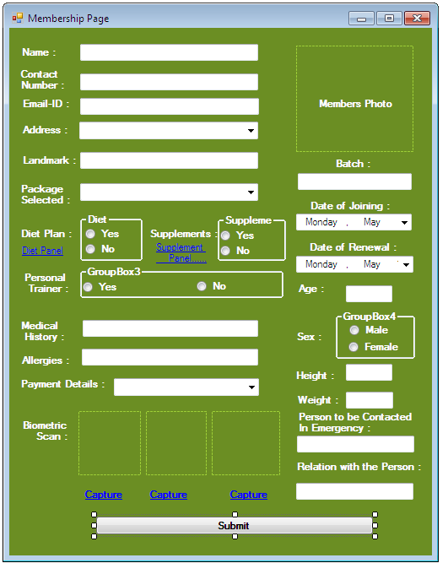

**Edited**

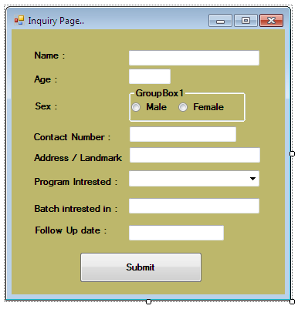

**Edited**

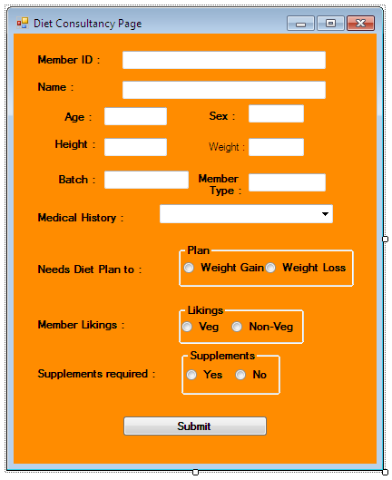

**Edited**

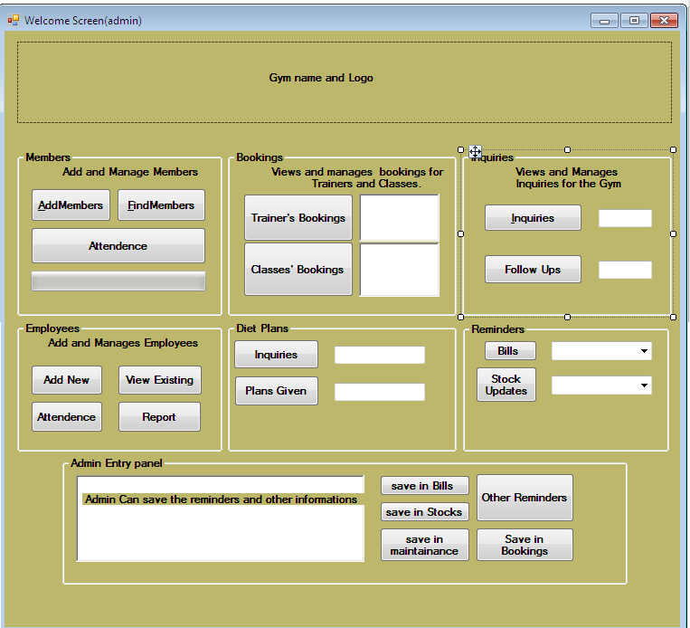

**Edited**

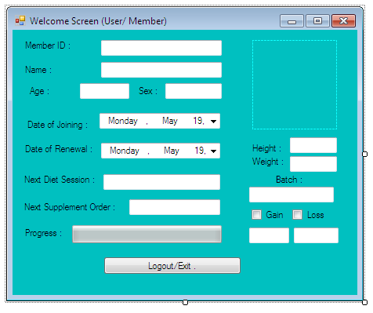

**Edited**

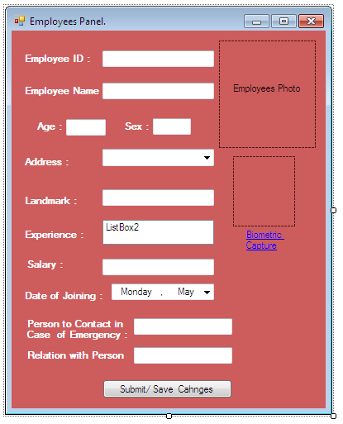

**Edited**

**Note: All the data required will be available in a day or two. Please help me further I the coding and other fronts of the developments. It’s the first project of eBuild Technologies.**

We assume that we got every data required before Due Time ankur.

Status: Open